Food Poisoning

**Food poisoning is caused by bacteria, and sometimes by viruses or other germs. They can get into the food we eat and the liquids we drink. We cannot notice it with taste, smell or see these germs (at least, without a microscope). But, even if they are tiny, they can have a great effect on our body.**

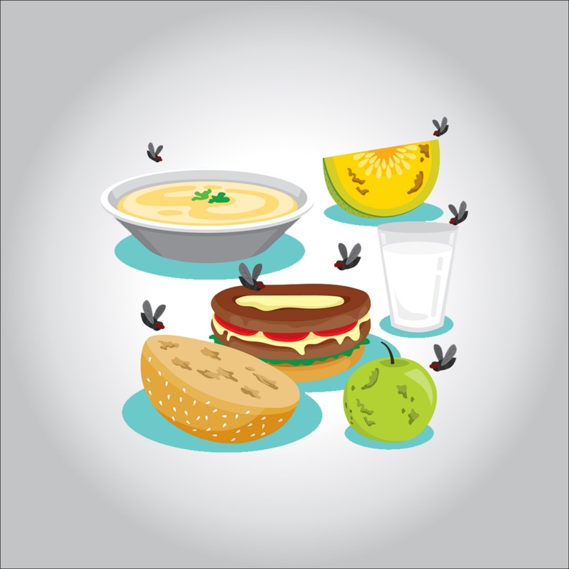

**When the germs that cause food poisoning enter our body, they can secrete toxins. These toxins are toxic (hence the name “food poisoning”), and can cause diarrhea and vomiting.**

**Doctors generally use the term “food poisoning” to describe a disease that develops quickly after eating a contaminated food. People often have diarrhea or start vomiting within a few hours of becoming infected. The good news is that food poisoning also usually subsides on its own in a short time. Most people recover in a couple of days and it doesn’t have any kind of sequel.**

**In a small number of cases, having food poisoning can mean going to the doctor or hospital. When people need medical treatment for food poisoning, it is usually due to dehydration. Dehydration is the most serious complication of food poisoning.**

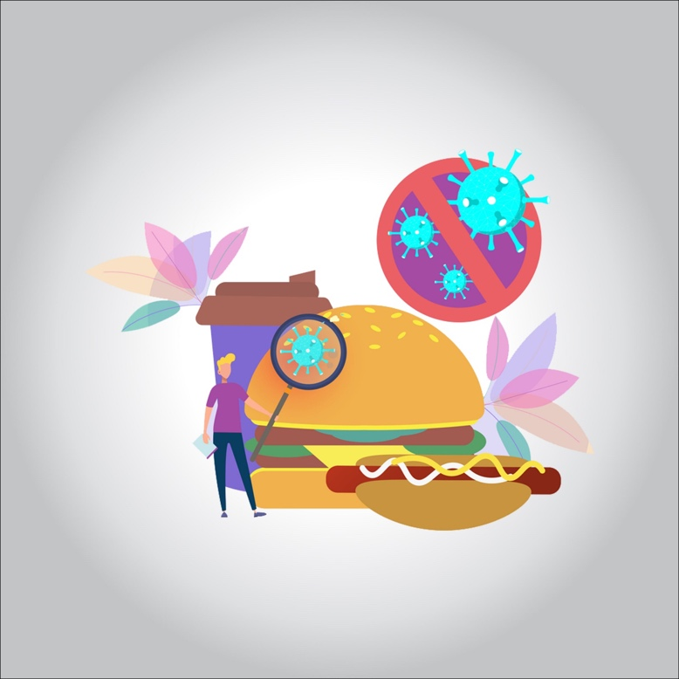

**What are the signs and symptoms of food poisoning?**

**The way in which food poisoning manifests depends on the germ that caused it. Sometimes a person will start to feel unwell within an hour or two of eating or due to the contaminated food or liquid. At other times, symptoms will not appear for several weeks. In most cases, symptoms will disappear within 1 to 10 days.**

**Most of the time, people with food poisoning have the following symptoms:**

* **sickness**
* **gut pain and cramps**
* **vomiting**
* **diarrhea**
* **fever**
* **headache and general weakness**

**Rarely, food poisoning can cause dizziness, blurred vision, or tingling in the arms. In even less frequent cases, the weakness that sometimes accompanies food poisoning will cause breathing problems.**

**Causes of food poisoning**

**When people eat or drink something that was contaminated with germs, they can get sick from food poisoning. People are frequently poisoned by foods of animal origin, such as meat in general and poultry, eggs, dairy products, and shellfish. But unwashed fruits and vegetables, as well as other raw foods, can also be contaminated and make people sick. Even water can cause food poisoning.**

**When should I call the doctor?**

**Most cases of food poisoning do not require medical attention, but there are some that do.  The most frequent serious problem of food poisoning is dehydration. If you are healthy, you are unlikely to become dehydrated as long as you drink enough fluids to make up for what you are losing through vomiting and / or diarrhea.**

**Call your doctor if you have any of these symptoms:**

* **your vomiting continues for more than 12 hours straight.**
* **diarrhea with a fever over 101 ° F (38.3 ° C)**
* **strong gut pain that does not go away after doing a stomach**
* **bloody stools (diarrhea or regular stools) or vomiting blood**
* **black or reddish stools**
* **fast heart rate or pounding heartbeat**

**If you are starting to have signs of dehydration, it is important that your mother or father knows about it. These include the following:**

* **extreme thirst**
* **poor pee production or no pee**
* **dizziness**
* **Hollow eyes**
* **fainting or weak feeling**

**How are food poisonings treated?**

**Generally, food poisoning runs its course, and people get better on their own.  But sometimes doctors prescribe antibiotics to treat the most serious types of food poisoning caused by bacteria. Someone with severe dehydration may need to be treated in a hospital with intravenous (VI) fluids.**

**Take care of yourself at home**

**Food poisoning usually goes away on its own within a few days. You can do a few things to take care of yourself.**

* **Rest a lot.**
* **Drink fluids to protect yourself from dehydration. Electrolyte solutions work well, but any liquid *except milk or drinks containing caffeine* is acceptable.**
* **Take small, frequent sips to help you retain fluids.**
* **Avoid solid foods and dairy products until you stop having diarrhea.**
* **Avoid over-the-counter antidiarrheal medications.  This type of medication can prolong the symptoms of food poisoning.**
* **When the diarrhea and vomiting stop, start eating small portions of low-fat, easy-to-digest foods for a few days to keep your stomach upset.**
* **If your symptoms worsen or you start to notice signs of dehydration, call your doctor.**

**How can I prevent food poisoning?**

**To reduce the risk of food poisoning, follow these tips:**

* **Wash your hands thoroughly and frequently, especially after using the bathroom, before touching food, and after touching raw food. Use warm soapy water, and make the process of scrubbing your hands last at least 20 seconds.**
* **Wash all utensils, cutting boards, and surfaces you use to prepare food with hot soapy water.**
* **Do not drink unpasteurized milk or foods that contain unpasteurized milk.**
* **Wash all raw vegetables and fruits that cannot be peeled.**
* **Keep raw foods (especially meat in general, poultry, and seafood) away from other foods until cooked.**
* **Consume perishable food or any food that has an expiration date as soon as possible.**
* **Cook all animal foods until they reach a safe internal temperature.**